SOLUTION OF MODULE 6
Question 1: https://www.hackerrank.com/challenges/staircase/problem
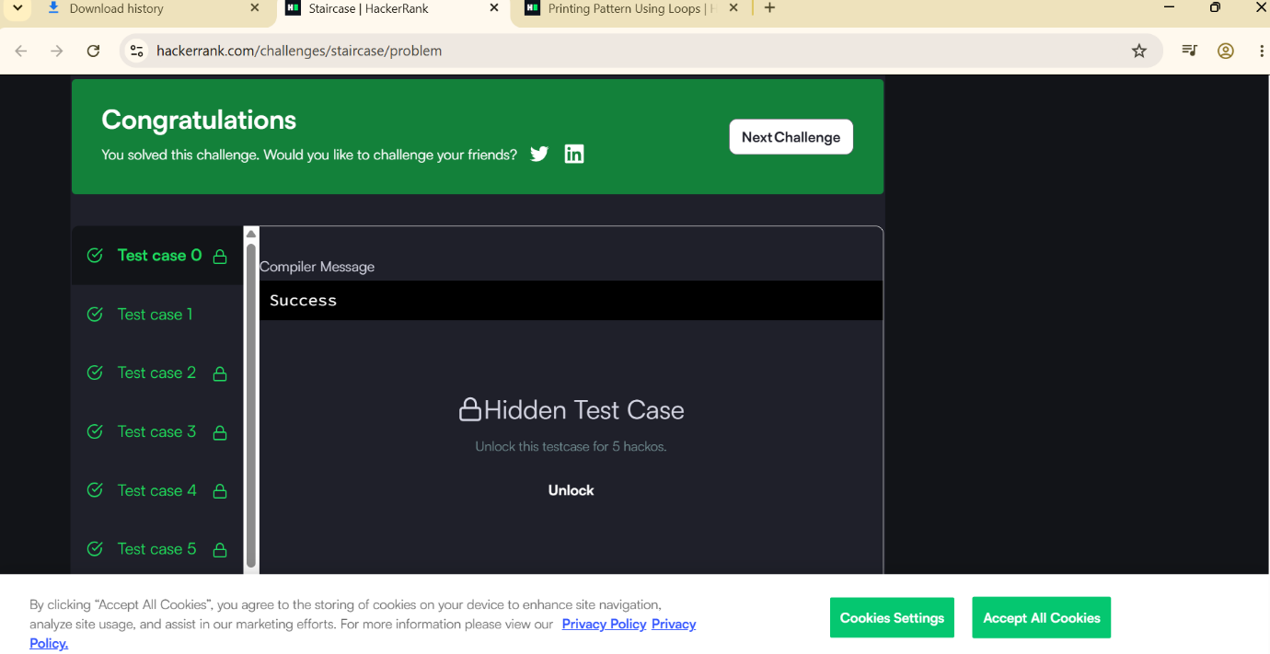

Question 2: https://www.hackerrank.com/challenges/printing-pattern-2/problem


